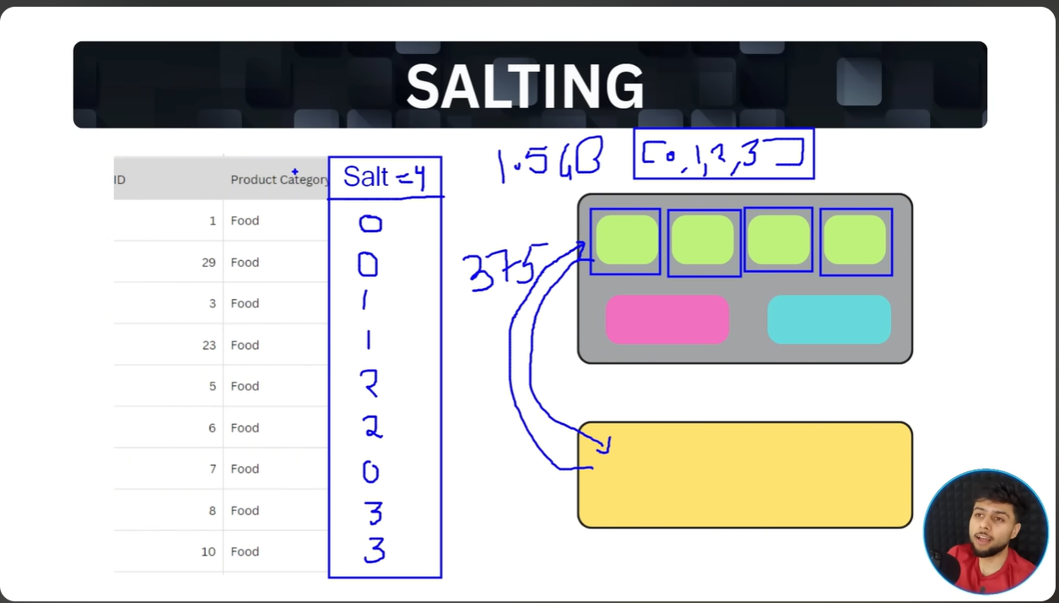
Salting is a technique where we divide the skewed data into partitions using random numbers (determined by dividing the skewed records into equal no.) by adding one salting column against the main column. . So here product category would be grouped with salting column numbers (eg. [Food , 0] would be grouped in one partition and similarly others)

